 | ISCG7421  Advanced Programme Development  Semester 2, 2017  Assignment 1B – MVC Project
Computer Science Practice Pathway | Approval Deadline: 8:30 p.m. 26th September 2016  Deadline Time: 5:30 p.m.  Deadline Date: Friday 27th October 2017  Demonstration Date: Tuesday 31st October 2017  Demonstration Time: 5:30 p.m. to 8:30 p.m.  Course Weighting: 35%  Marks: 100

Yixin, Zhang 1483998

Screen designs

View1
The first view allows the user to view, add, modify and delete objects (of the model’s sub-classes 1, 2, & 3) in a text format.

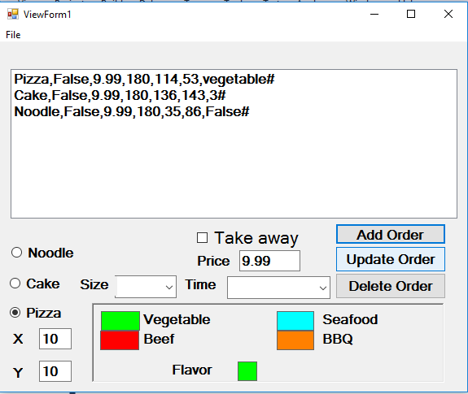

View2

The second view allows the user to view, modify or delete objects (of the model’s sub-classes 1, 2, & 3) in a graphic format. This graphic view shows graphics that are redrawn if the form needs to repaint itself.
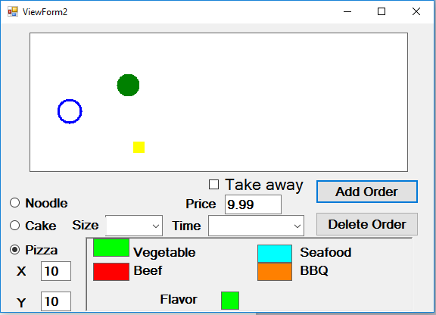

View3
The third view is a read-only view that filters out objects of one of my sub-classes (model’s sub-class 1, 2, or 3). This filtered view shows graphics that are redrawn if the form needs to repaint itself.

Use Case diagram

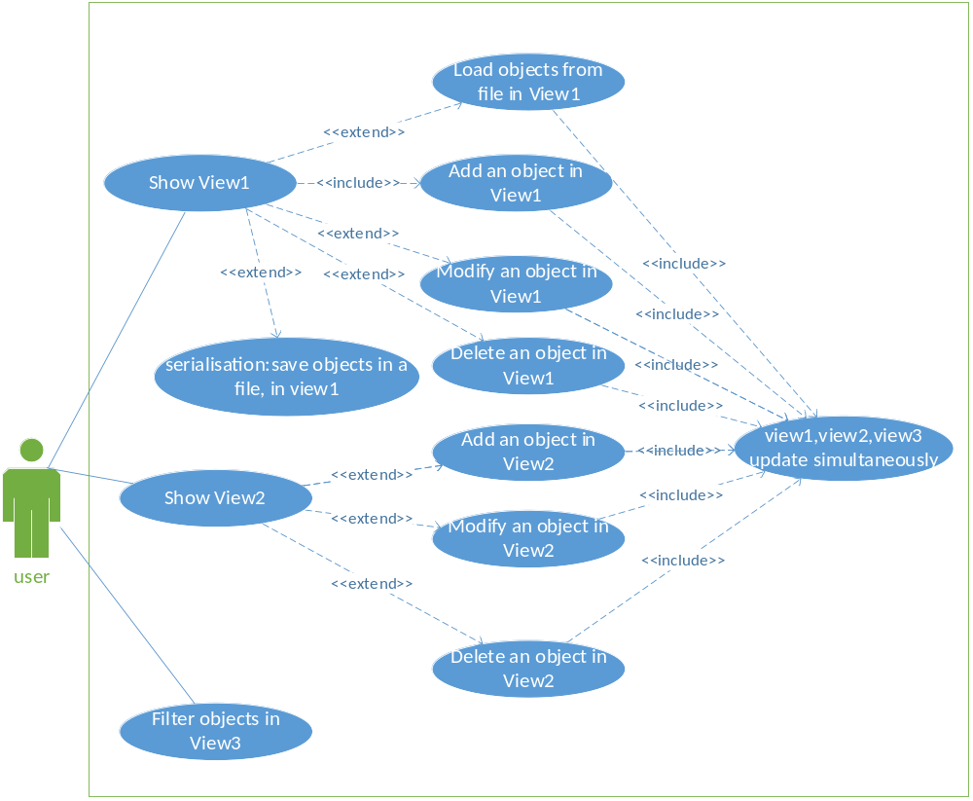

Activity diagrams

View1 Activity Diagram

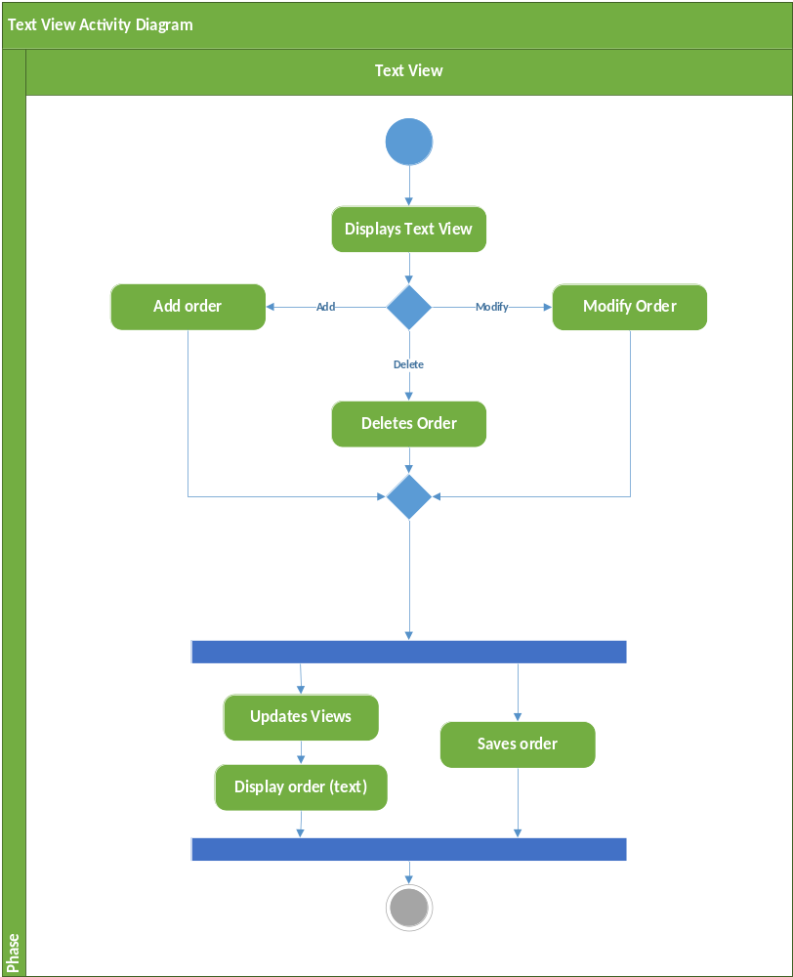

View2 Activity Diagram
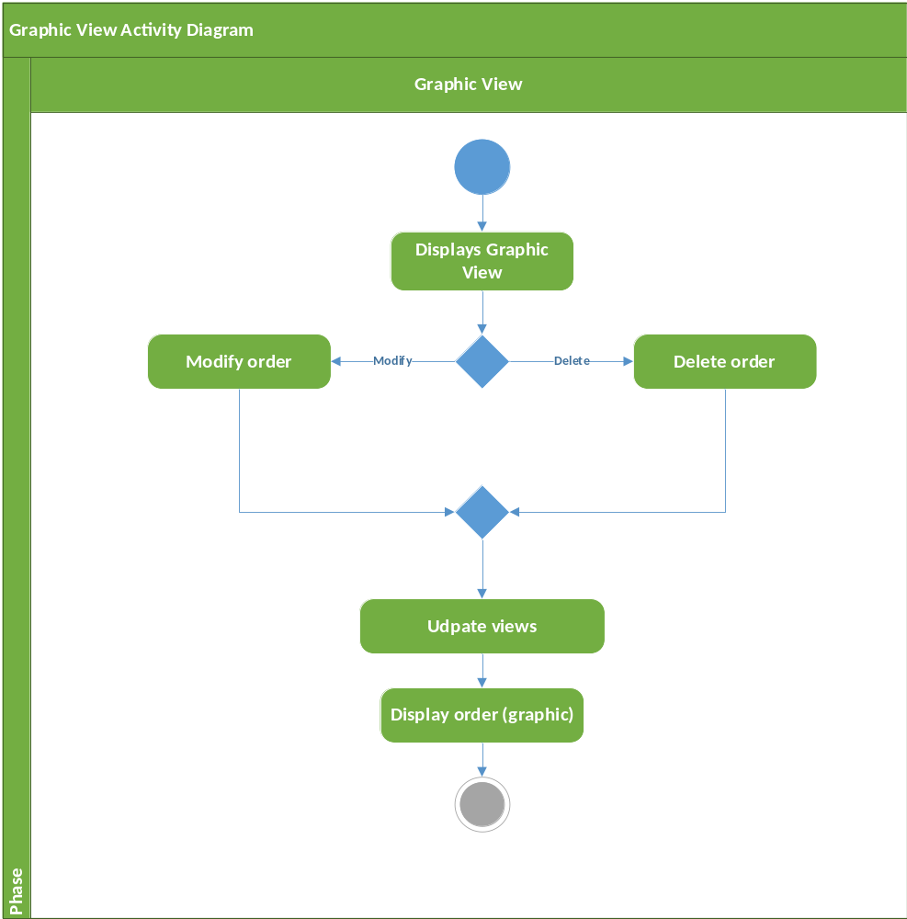

View3 Activity Diagram
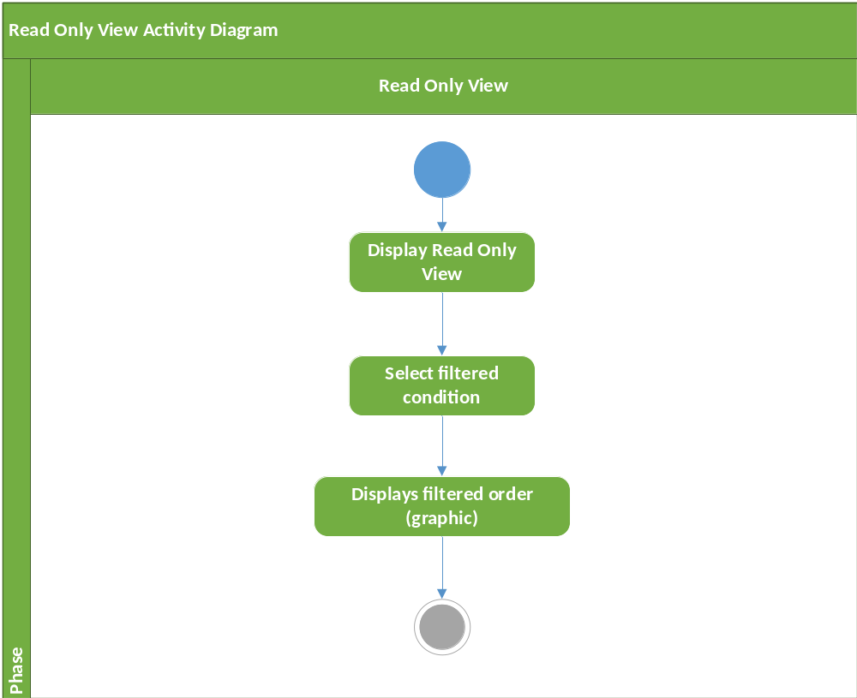
Class diagram

